|  |  |
| --- | --- |
| No. of Pages | 2 |
| No. of Questions | 9 |

**Student Name: ________________________________ID:____________________**

**Department of Computer Science and Engineering**

**Midterm Examination FALL 2015**

**CSE420: Compiler Design**

**Total Marks: 40 Time Allowed: 1 Hour**

|  |
| --- |
| * You HAVE TO RETURN this question paper and the answer script at the end of the exam. Your script will not be checked unless you do so. * You are not allowed to communicate with any other candidate in any way what so ever. |

**Section A**

1. What would the transition diagram (TD) for **strings containing each vowel**, in their **strict lexicographical order**, look like? [4]

2. What are the **error recovery strategies** generally used by parser? [2]

3. Convert following NFA to DFA using **subset construction methodology**. [8]

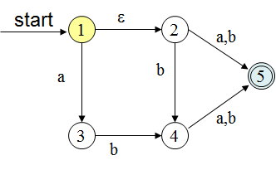

4. Consider the following grammar:

X → YaYb | ZbZa

Y → b

Z → a | €

1. Do a **top-down** **leftmost** derivation of “baa”.
2. Do a **bottom-up** **rightmost** derivation of “babb”. [3 + 3]

5. Define **Symbol Table**. [2]

6. **Left factor** following grammar:

A -> α β | α γ

Remove **Left recursion** from following grammar:

A -> A α [1+1]

**Section B**

7. Determine the **LR(1) automation** and **parse table** for following grammar.

S → Aa

S → bAc

S → dc

S → bda

A → d [5+5]

(9) **Parse** input string “**baab”** using following grammar and parsing table:

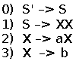 [6]

